

Semester Two Examination, 2018

Question/Answer booklet

MATHEMATICS

SOLUTIONS
SPECIALIST
UNITS 3 AND 4

Section One:

Calculator-free

Student number: In figures

In words

Your name

Time allowed for this section
Reading time before commencing work: five minutes
Working time: fifty minutes

Materials required/recommended for this section
To be provided by the supervisor
This Question/Answer booklet
Formula sheet

To be provided by the candidate
Standard items: pens (blue/black preferred), pencils (including coloured), sharpener,
correction fluid/tape, eraser, ruler, highlighters

Special items: nil

Important note to candidates
No other items may be taken into the examination room. It is your responsibility to ensure that you do not have any unauthorised material. If you have any unauthorised material with you, hand it to the supervisor before reading any further.

Structure of this paper

Section | Number of questions available | Number of questions to be answered | Working  time (minutes) | Marks available
Section One:  Calculator-free | 8 | 8 | 50 | 53
Section Two:  Calculator-assumed | 13 | 13 | 100 | 98
 |  |  |  | 151

Instructions to candidates

1. The rules for the conduct of examinations are detailed in the school handbook. Sitting this examination implies that you agree to abide by these rules.

2. Write your answers in this Question/Answer booklet.

3. You must be careful to confine your response to the specific question asked and to follow any instructions that are specified to a particular question.

4. Supplementary pages for the use of planning/continuing your answer to a question
have been provided at the end of this Question/Answer booklet. If you use these pages to continue an answer, indicate at the original answer where the answer is continued, i.e. give the page number.

5. Show all your working clearly. Your working should be in sufficient detail to allow your answers to be checked readily and for marks to be awarded for reasoning. Incorrect answers given without supporting reasoning cannot be allocated any marks. For any question or part question worth more than two marks, valid working or justification is required to receive full marks. If you repeat any question, ensure that you cancel the answer you do not wish to have marked.

6. It is recommended that you do not use pencil, except in diagrams.

7. The Formula sheet is not to be handed in with your Question/Answer booklet.

Section One: Calculator-free 35% (53 Marks)
This section has eight (8) questions. Answer all questions. Write your answers in the spaces provided.

Working time: 50 minutes.

Question 1 (4 marks)
Consider the equation $9z^{3}-18z^{2}+5z-10=0$.

(a) Show that $z=2$ is a solution of the equation. (1 mark)
Solution
$$LHS=9\left(8\right)-18\left(4\right)+5\left(2\right)-10 \\ =72-72+10-10 \\ =0$$

Specific behaviours
fully expands each term

(b) Determine $2$ other solutions of the equation. (3 marks)
Solution
$$9z^{3}-18z^{2}+5z-10=\left(z-2\right)\left({9z}^{2}+kz+5\right)$$
$$∴k=0$$
$$z^{2}=-\frac{5}{9}$$
$$z=±\frac{\sqrt{5}i}{3}$$

Specific behaviours
factors cubic
✓ expression for $z^{2}$
✓ both solutions, simplified

Question 2 (5 marks)
Part of the graph of $y=1+\begin{matrix}4 \\ \overline{x(x-5)}\end{matrix}$ is shown below.

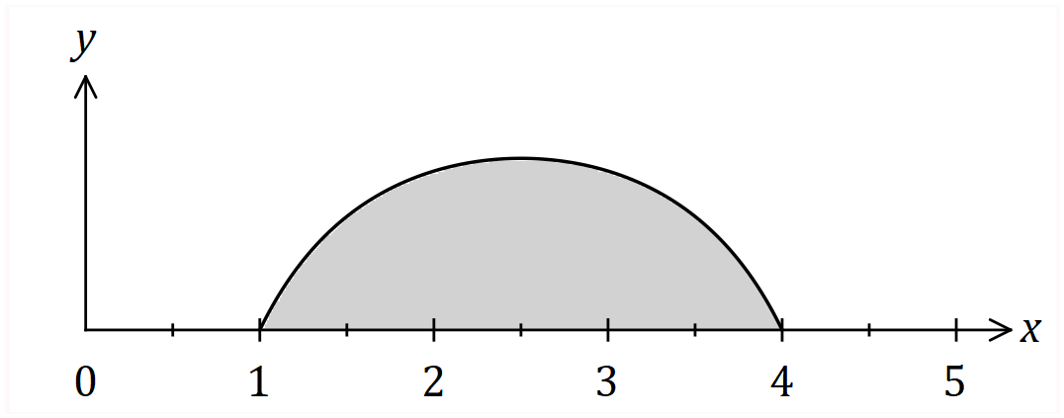

Determine the shaded area, bounded by the curve and the $x$-axis.
Solution
$$A=\int_{1}^{4}{1+\frac{4}{x\left(x-5\right)}}dx$$

$$\frac{1}{x\left(x-5\right)}=\frac{1}{-5}×\frac{1}{x}+\frac{1}{5}×\frac{1}{x-5}$$

$$\int_{1}^{4}{1+\frac{4}{x\left(x-5\right)}}dx=\int_{1}^{4}{1}dx+\frac{4}{5}\int_{1}^{4}{\frac{1}{x-5}-\frac{1}{x}}dx \\ =3+\frac{4}{5}{\left[\ln\left|x-5\right|-\ln\left|x\right|\right]}_{1}^{4} \\ =3+\frac{4}{5}\left[\ln\left(\frac{1}{4}\right)-\ln\left(\frac{4}{1}\right)\right] \\ =3+\frac{4}{5}\ln\left(\frac{1}{16}\right) \\ =3-\frac{16}{5}\ln{(2)}$$

Specific behaviours
✓ integral, recognising need for partial fractions
✓ obtains partial fractions
✓ integrates
✓ substitutes limits of integration
✓ simplifies until just one logarithm remains

Question 3 (4 marks)
The curve defined by $y=4\cos\left(\begin{matrix}πx \\ \overline{ 12 }\end{matrix}\right)$, where $0≤x≤3$, is shown below.

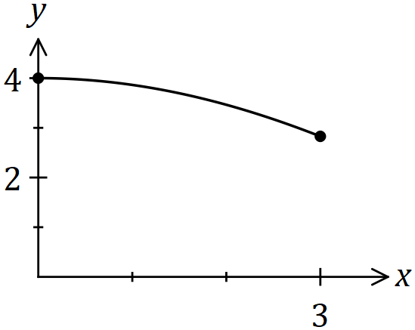

Determine the volume of the solid generated when the area bounded by the $x$ axis and the curve is rotated $360°$ about the $x$ axis between $x=0$ and $x=3$.
Solution
$$V=π\int_{0}^{3}{y^{2}}dx \\ =16π\int_{0}^{3}{\cos^{2}\left(\frac{πx}{12}\right)dx} \\ =\frac{16π}{2}\int_{0}^{3}{\left(1+\cos\left(\frac{πx}{6}\right)\right)}dx \\ =8π{\left[x+\frac{6}{π}\sin\left(\frac{πx}{6}\right)\right]}_{0}^{3} \\ =8π\left(\left[3+\frac{6}{π}\right]-\left[0+0\right]\right) \\ =24π+48 \text{cubic units}$$

Specific behaviours
writes integral
✓ re-writes integral using double angle identity
✓ integrates
✓ substitutes both bounds and simplifies

Question 4 (8 marks)
Two planes have equations $x+2y-z+3=0$ and $2x-y+z-10=0$.
(a) Determine the Cartesian equation of a third plane that is perpendicular to these planes and passes through the point $(2, 1, 0)$. (4 marks)
Solution
$$\left(\begin{matrix}1 \\ 2 \\ -1\end{matrix}\right)×\left(\begin{matrix}2 \\ -1 \\ 1\end{matrix}\right)=\left(\begin{matrix}1 \\ -3 \\ -5\end{matrix}\right)$$

$$\left(\begin{matrix}1 \\ -3 \\ -5\end{matrix}\right)∙\left(\begin{matrix}2 \\ 1 \\ 0\end{matrix}\right)=-1$$

$$x-3y-5z=-1$$

Specific behaviours
identifies normal vectors to both planes
✓ uses cross product
✓ uses point
✓ correct equation

(b) Determine the point of intersection of all three planes. (4 marks)
Solution
$$x+2y-z=-3 (1) \\ 2x-y+z=10 (2) \\ x-3y-5z=-1 (3)$$

$$5y-3z=-16 \boxed{ 2\left(1\right)-(2)} \\ 5y+4z=-2 \boxed{\left(1\right)-(3)} \\ -7z=-14⇒z=2$$

$$5y+8=-2⇒y=-2 \\ x-4-2=-3⇒x=3$$

$$\text{Intersect at} (3, -2, 2)$$

Specific behaviours
eliminates variable
✓ eliminates same variable
✓ solves for first variable
✓ states solution

Question 5 (9 marks)
Let $w=\begin{matrix}1+i \\ \overline{\sqrt{3}-i}\end{matrix}$.

(a) Determine the real constants $a$ and $b$, where $w=a+ib$. (2 marks)
Solution
$$\frac{\left(1+i\right)\left(\sqrt{3}+i\right)}{\left(\sqrt{3}-i\right)\left(\sqrt{3}+i\right)}=\frac{\sqrt{3}-1+i\left(1+\sqrt{3}\right)}{4}$$

$$a=\frac{\sqrt{3}-1}{4}, b=\frac{1+\sqrt{3}}{4}$$

Specific behaviours
rationalises
✓ states values

(b) By first expressing $1+i$ and $\sqrt{3}-i$ in polar form, write $w$ in polar form. (3 marks)
Solution
$$1+i=\sqrt{2}\operatorname{cis}{\frac{π}{4}}, \sqrt{3}-i=2\operatorname{cis}{-\frac{π}{6}}$$

$$w=\frac{\sqrt{2}}{2}\operatorname{cis}{\frac{5π}{12}}$$

Specific behaviours
expresses terms in polar form
✓ modulus of $w$
✓ argument of $w$

(c) Hence determine an exact value for $\cos\left(\begin{matrix}5π \\ \overline{12}\end{matrix}\right)$. (2 marks)
Solution
$$\frac{\sqrt{2}}{2}\left(\cos{\frac{5π}{12}}+i\sin{\frac{5π}{12}}\right)=\frac{\sqrt{3}-1+i\left(1+\sqrt{3}\right)}{4}$$

$$\cos{\frac{5π}{12}}=\frac{2}{\sqrt{2}}×\frac{\sqrt{3}-1}{4}=\frac{\sqrt{2}(\sqrt{3}-1)}{4}$$

Specific behaviours
equates real parts
✓ states exact value

(d) Determine $w^{12}$ in Cartesian form. (2 marks)
Solution
$$w^{12}={\left(\frac{\sqrt{2}}{2}\operatorname{cis}{\frac{5π}{12}}\right)}^{12}={\left(\frac{1}{\sqrt{2}}\right)}^{12}\operatorname{cis}\left(5π\right)=-\frac{1}{64}$$

Specific behaviours
applies de Moivre's Theorem
✓ correct value

Question 6 (9 marks)
The graph of $y=\begin{matrix}x^{2}-4x \\ \overline{ x-3 }\end{matrix}$ and its two asymptotes is shown below.

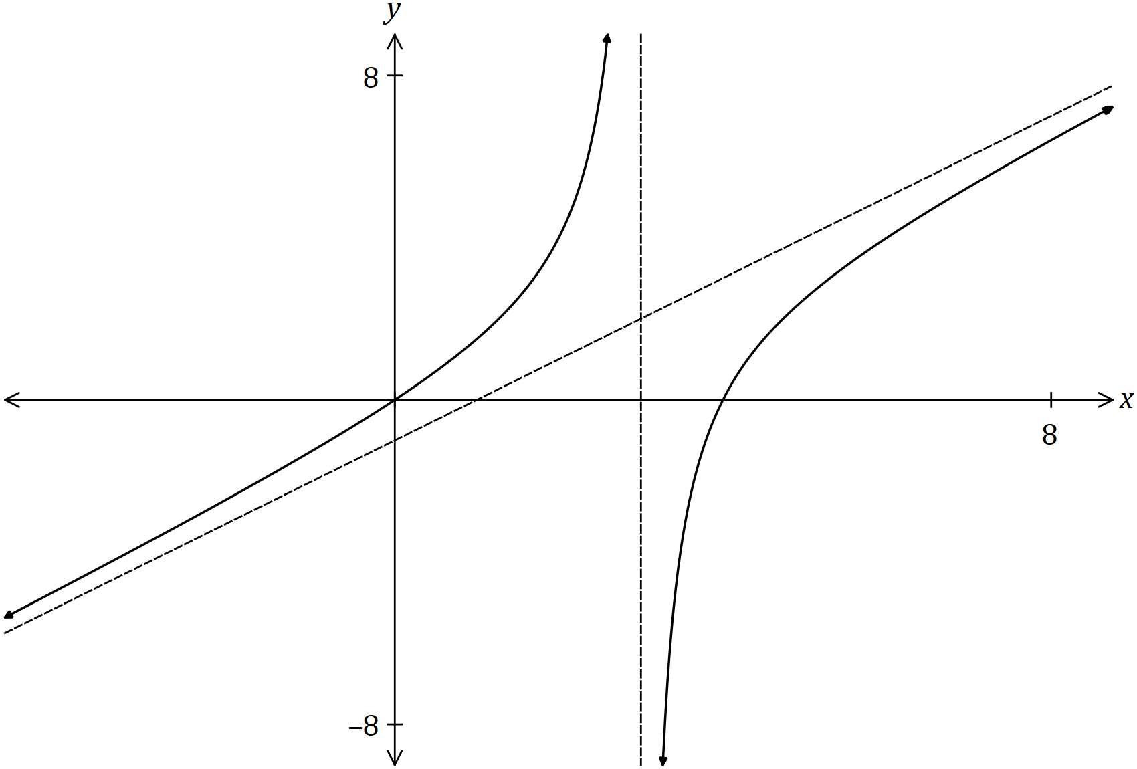

(a) Determine the equation of both asymptotes. (3 marks)
Solution
$$\frac{x^{2}-4x}{x-3}=\frac{x^{2}-3x}{x-3}+\frac{-x+3}{x-3}+\frac{-3}{x-3} \\ =x-1-\frac{3}{x-3}$$

$$y=x-1 \text{and} x=3$$

Specific behaviours
vertical asymptote
✓ writes equation as proper fraction or similar
✓ oblique asymptote

(b) On the axes below, sketch the graph of $y=\begin{matrix}x-3 \\ \overline{x^{2}-4x}\end{matrix}$. (4 marks)

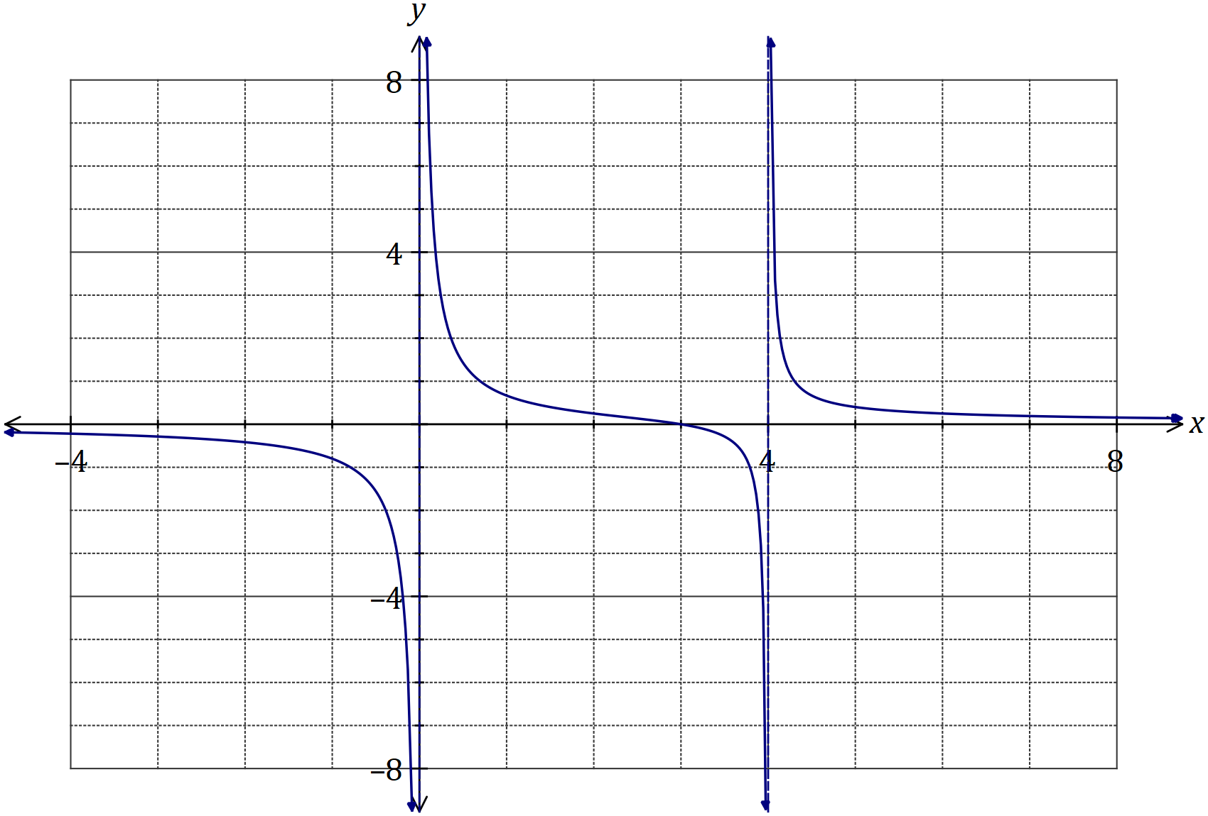
Solution
See graph
Specific behaviours
vertical asymptotes at $x=0, 4$
root at $x=3$
$y→0$ for $x→±∞$
correct curvature between asymptotes

(c) On the axes below, sketch the graph of $y=\begin{matrix}x^{2}-4|x| \\ \overline{ |x|-3 }\end{matrix}$. (2 marks)

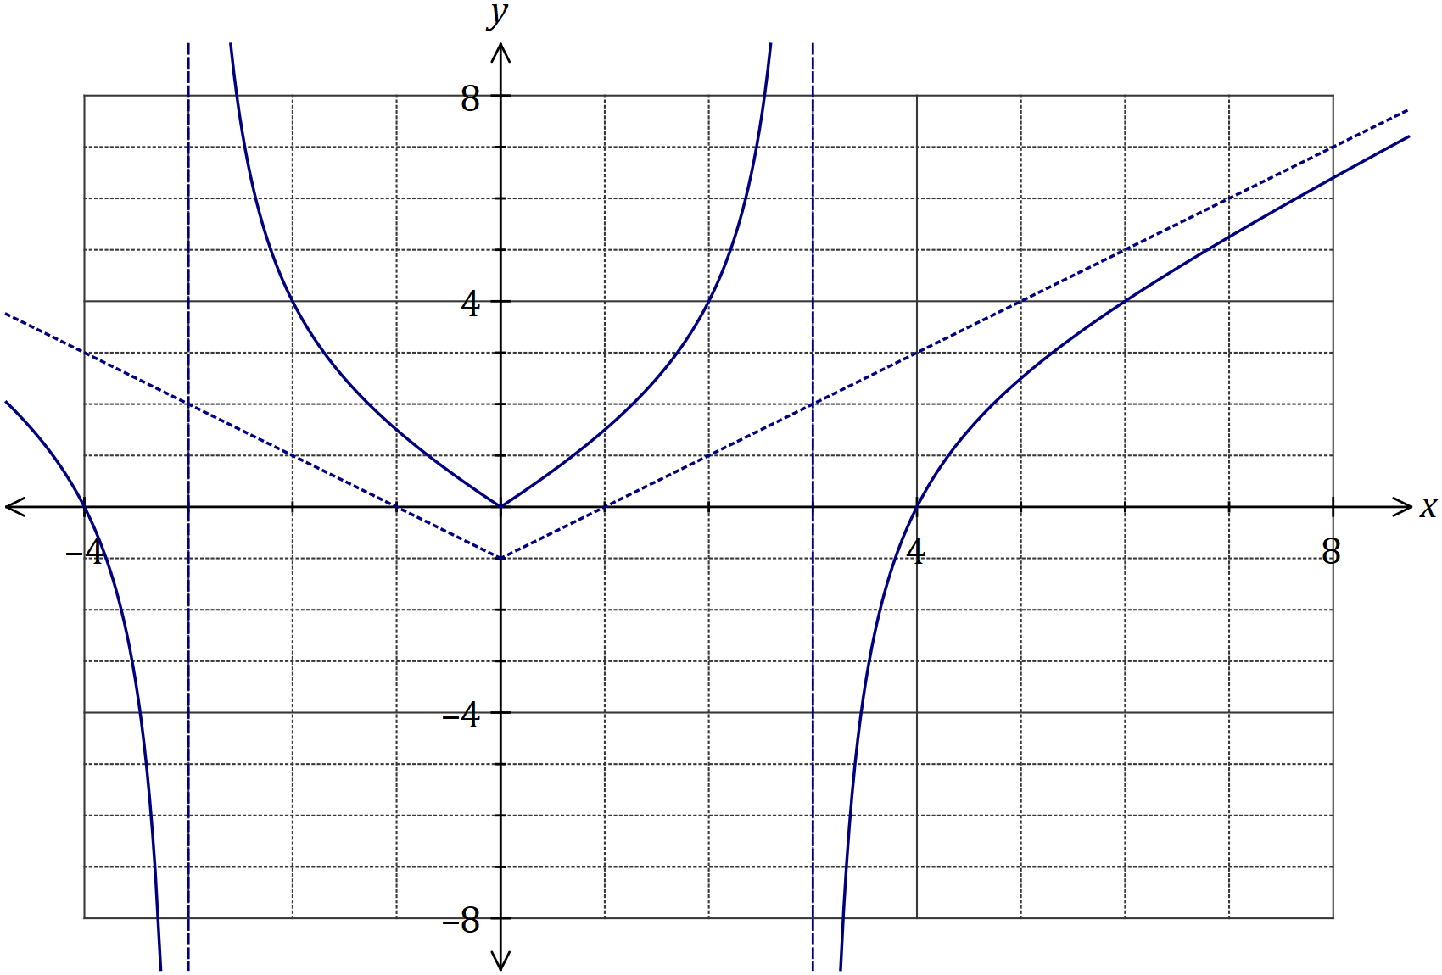
Solution
See graph
Specific behaviours
reflects part of graph $x≥0$ in $x=0$
all asymptotes and roots

Question 7 (7 marks)
Function $f$ is defined as $f\left(x\right)=\sqrt{1-2x}$ and function $g$ is defined as $g\left(x\right)=\log_{e}{(5+x)}$.

(a) Determine a rule for $f^{-1}(x)$, the inverse of $f$, and state its domain and range. (3 marks)
Solution
$${1-y}^{2}=2x$$

$$f^{-1}\left(x\right)=\frac{1}{2}(1-x^{2})$$

$$D:\left\{x≥0:x∈R\right\}$$

$$R:\left\{f^{-1}(x)≤\frac{1}{2}:f^{-1}(x)∈R\right\}$$

Specific behaviours
obtains rule for $f^{-1}\left(x\right)$
✓ states domain
✓ states range

(b) Determine an expression for $f∘g(x)$ and state its domain. (4 marks)
Solution
$$D_{g}:x>-5$$

$$f∘g\left(x\right)=\sqrt{1-2ln\left(5+x\right)}$$

$$1-2\ln\left(5+x\right)≥0 \\ 5+x≤e^{\frac{1}{2}}$$

$$D_{fg}: \left\{-5<x≤\sqrt{e}-5:x∈R\right\}$$

Specific behaviours
writes composite function
✓ notes domain of $g$
✓ inequality using radicand
✓ states correct domain

Question 8 (7 marks)
On the Argand planes below, sketch the locus of the complex number $z$ given by the following.

(a) $\left|z-1-i\right|=|z-3+i|$. (3 marks)

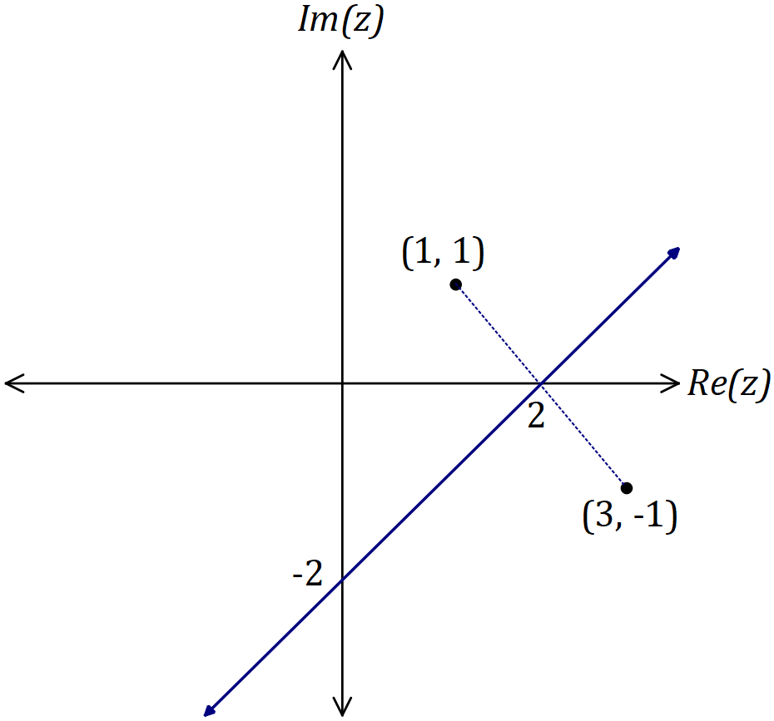
Solution
$$\left|z-(1+i)\right|=|z-(3-i)|$$

See graph
Specific behaviours
plots 2 points
✓ forms perpendicular bisector
✓ indicates axes intercepts

(b) $\begin{matrix}1 \\ \overline{\overset{ }{ z} }\end{matrix}+\begin{matrix}1 \\ \overline{\overset{ __}{ z} }\end{matrix}+\begin{matrix}1 \\ \overline{4}\end{matrix}=0, z≠0$. (4 marks)

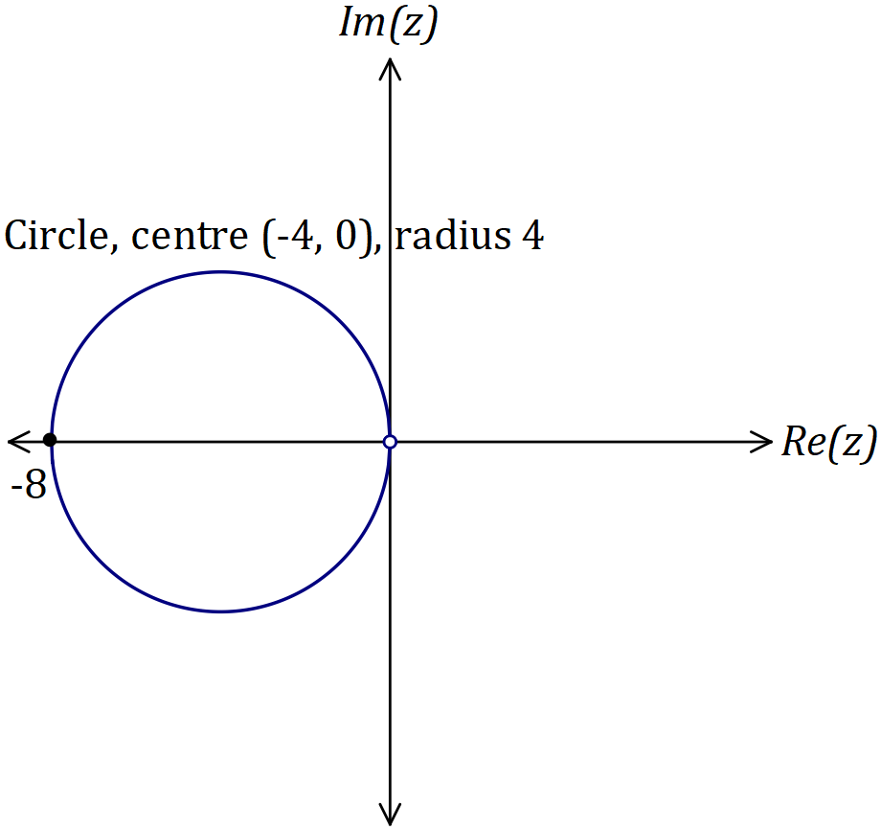
Solution
$$\overline{z}+z+\frac{z∙\overline{z}}{4}=0$$
$$z=x+iy⇒8x+x^{2}+y^{2}=0$$
$${\left(x+4\right)}^{2}+y^{2}=4^{2}$$

See graph
Specific behaviours
multiplies equation by $z∙\overline{z}$
✓ simplifies, with $z=x+iy$
✓ circle with correct centre and radius
✓ excludes (0, 0)

Supplementary page

Question number: _________

Supplementary page

Question number: _________

Supplementary page

Question number: _________

Supplementary page

Question number: _________

© 2018 WA Exam Papers. Hale School has a non-exclusive licence to copy and communicate this document for non-commercial, educational use within the school. No other copying, communication or use is permitted without the express written permission of WA Exam Papers. SN035-124-2.

